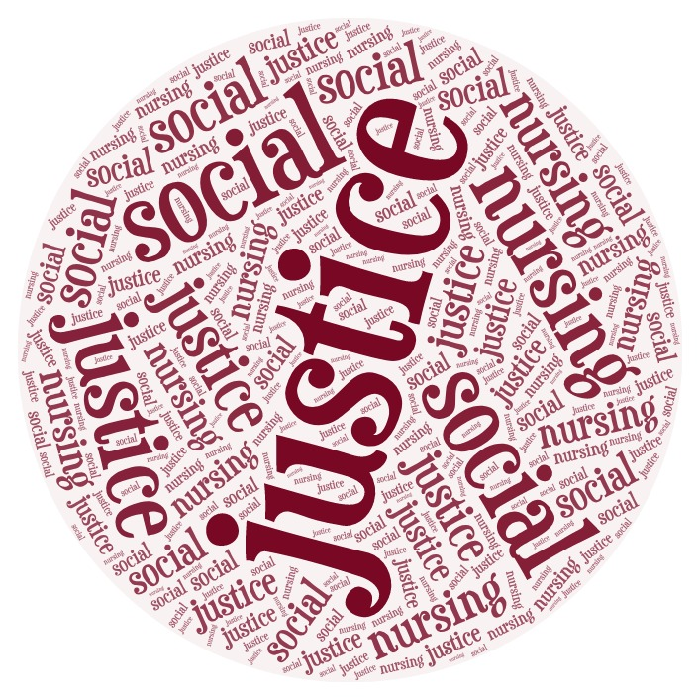  The Social Justice  Nursing Conference  York University, Toronto, Ontario  June 13, 2019  York University’s School of Nursing is pleased to announce a conference reflecting on nursing’s legacy and ethical imperative to steadfastly advocate for social justice. The Social Justice Nursing Conference coincides with the school’s 25th anniversary and inaugural June Awrey Lecture featuring Dr. Lisa Bourque-Bearskin, RN, PhD - a member of the Beaver Lake Cree Nation, past president of the Canadian Indigenous Nurses’ Association (CINA) and Associate Professor and researcher with the Thompson Rivers University, School of Nursing.  The Canadian Nurses Association recently reaffirmed the centrality of social justice as a focus for nursing viewing it as “means to an end and an end in itself,” and acknowledging its consistency with the values set out in our code of ethics (CNA, 2010; CNA, 2017). Critical community health nurse, Dr. Benita Cohen (2010) invites nurses in all settings to take four key advocacy steps in order to enact a social justice ethic, including: equipping ourselves with the facts, challenging societal beliefs about individual responsibility for health, promoting equity considerations in health policy and program planning within our own organization, and  working to bring about social change. To that end, abstract submissions are warmly invited reflecting any combination of these four themes:  - Critical analyses of health inequities and the role of nurses/nursing;  - Strategies to challenge societal beliefs, policies or health care practices which contribute to the marginalization or victim-blaming of populations experiencing poor health;  - Innovations in practice, policy, education or research aimed at promoting social justice and equity;  - Calls for action or Lessons learned from exemplars of nursing-involved social activism.  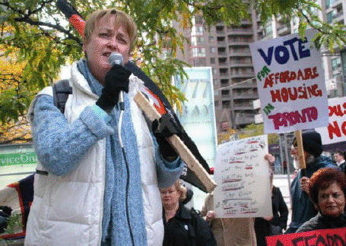 | “Social injustice is killing people on a grand scale.”  (WHO, 2008)  ────  Keynote Address  Dr. Lisa Bourque-Bearskin, RN, PhD  ────  Keele Campus, Bergeron Centre 11 Arboretum Lane, North York, ON  Abstracts Due:  March 1, 2019 to:  nursconf@yorku.ca  ────  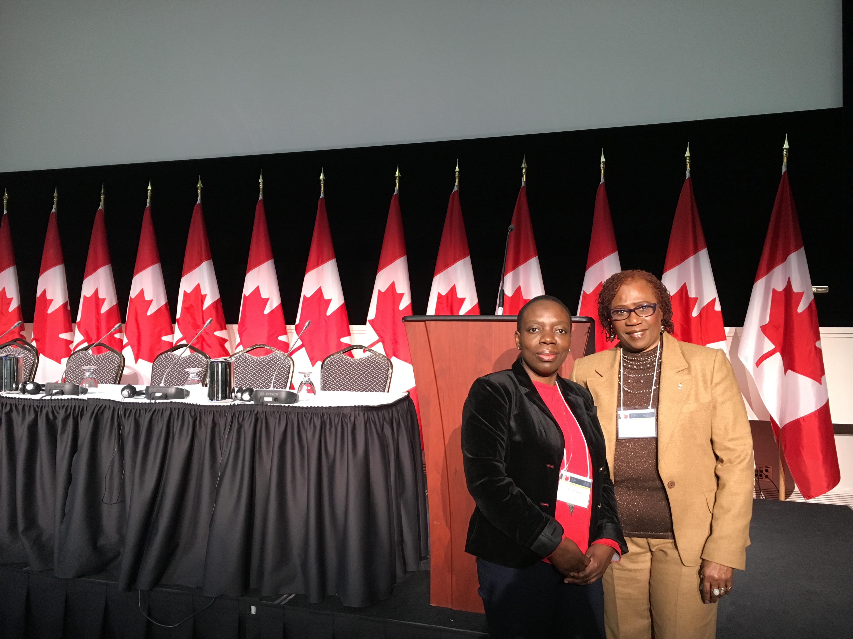
The Social Justice Nursing Conference
York University, Toronto, Ontario at The Bergeron Centre.
June 13th, 2019
CALL FOR ABSTRACTS
York University’s School of Nursing is pleased to announce a conference reflecting on nursing’s legacy and ethical imperative to steadfastly advocate for Social Justice. The Social Justice Nursing Conference coincides with the School of Nursing’s 25th anniversary and inaugural June Awrey Lecture.
Just over a decade ago, the WHO’s (2008) commission on the social determinants of health concluded that social injustice was killing people on a grand scale. With increasing health inequities (i.e. disparities in health and quality of life rooted in marginalization and/or social disadvantage), the role of nursing advocacy to affect social change through practice, leadership, policy and education is crucial. Indeed, the Canadian Nurses Association recently reaffirmed the centrality of social justice as a focus for nursing viewing it as “means to an end and an end in itself,” acknowledging its consistency with the values set out in our code of ethics (CNA, 2010; CNA, 2017). Critical community health nurse, Dr. Benita Cohen (2010) invites nurses in any setting to take four key advocacy steps in order to enact a social justice practice, including: equipping ourselves with the facts, challenging societal beliefs about individual responsibility for health, promoting equity considerations in health policy and program planning within our own organization, and working to bring about social change. To that end, abstract submissions are warmly invited reflecting any combination of these four themes:
- Critical analyses of health inequities and the role of nurses/nursing;

- Strategies to challenge societal beliefs, policies or health care practices which contribute to the marginalization or victim-blaming of populations experiencing poor health;

- Innovations in practice, policy, education or research aimed at promoting social justice and equity;

- Calls for action or Lessons learned from exemplars of nursing-involved social activism.

Abstract submissions will be accepted for either a 20-minute panel presentation or a poster presentation. Undergraduate and graduate students are especially encouraged to submit an abstract for our planned student poster event. Abstracts should pertain to an aspect of social justice nursing, where efforts to address health inequities are made explicit. You are welcome to contact the conference co-chairs to discuss your ideas.
Abstract submissions are encouraged from nurses in practice, administration, education, research, government, NGOs and policy. Student submissions are encouraged! Accepted abstracts will then be organized into theme-based panel presentations.
For more information please contact the conference co-chairs Dr. Mina Singh, Associate Director – Research at (minsingh@yorku.ca ) or Dr. Cheryl van Daalen-Smith (cvandaal@yorku.ca )
Visit our website for updates along the way! https://nursingconf.info.yorku.ca/sjnc/

FORMAT
Panel presentations are 20 minutes in length with 10 minutes for questions and organized into a thematic panel of 2 speakers.
Poster presentations will take place over the lunch hour in ‘market’ style. Posters will be displayed for the duration of one hour. Presenters are expected to be at their poster during the one-hour period and be prepared to present to interested audience.
WHAT TO SUBMIT?
You are invited to submit an abstract of no more than 300 words. In your abstract, identify how your proposed talk is linked to social justice nursing and identify which of the four themes it aligns with. Please identify whether your abstract is to be considered for a panel or poster presentation. Please also submit a bio of all the presenters as a separate attachment. See Abstract submission form at the end of this call for submissions.
Please submit abstract submission form no later than 23:59 EST on March 1, 2019 to nursconf@yorku.ca
SELECTION PROCESS
All abstracts are subjected to a masked peer review.
IMPORTANT DATES
All abstracts will be acknowledged on the date they are received. Abstracts will be accepted until 11:59pm EST on March 1, 2019. The selection process will be completed and contributors will be notified by April 1, 2019.
NOTE: All presenters are responsible for all expenses incurred and must register for the conference prior to April 15th , 2019.

CONFERENCE WEBSITE: https://nursingconf.info.yorku.ca/sjnc/
Sources Cited:
Canadian Nurses Association (2010). Social Justice: A Means to an End. An End in itself. 2nd Ed. Retrieved from: https://www.cna-aiic.ca/~/media/cna/page-content/pdf-en/social_justice_2010_e.pdf
Canadian Nurses Association (2017) Code of Ethics for Registered Nurses. Retrieved from: https://www.cna-aiic.ca/html/en/Code-of-Ethics-2017-Edition/files/assets/basic-html/page-1.html
Cohen, B. (2010). From witness to social justice advocate. The Canadian Nurse Journal, The last word. September. Retrieved from: https://www.canadian-nurse.com/articles/issues/2010/september-2010/from-witness-to-social-justice-advocate .
World Health Organization (2008) Closing the gap in a generation: Health equity through action on the social determinants of health. Commission on the Social Determinants of Health. Geneva, Switzerland. Retrieved from: https://www.who.int/social_determinants/thecommission/finalreport/en/

